

SECP1513-02 TECHNOLOGY AND INFORMATION SYSTEM

Design Thinking Project Report

Project Title: Student Engagement and Wellness Analytics

Group 10: TechNexus

Lecturer: Dr. Aryati binti Bakri

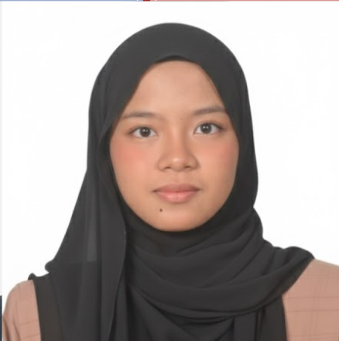  Name: Nur Nazirah Hanis binti Nazri  Matric No. : A25CS0319 |   Name: Humayra’ binti Zulqarnain  Matric No. : A25CS0068
  Name: Ng Xuan Yee  Matric No. : A25CS0291 |   Name: Nur Hanani Sazwani binti Muhammad Helmi Wan  Matric No. : A25CS0313

CONTENTS

No. | Topic | Page
1. | Introduction | 3
2. | Detail Steps | 5
3. | Detailed Description | 8
4. | Design Thinking Assessment Points | 10
5. | Design Thinking Evidence | 12
6. | Reflection | 28
7. | Task Distribution | 34
8. | Conclusion | 35
9. | References | 36

INTRODUCTION

1.1 Background Statement | A study conducted earlier has defined student engagement (D.Axelson & Flick, 2010) as how involved a student is in their studies and how connected they are to their respective classes, institutions and each other. Another way to define student engagement is to investigate and identify how it is measured using quantitative data such as truancy, test scores, attendance, and homework completion (Taylor & Parsons, 2011).  One of the reasons for poor academic performance is mental distress due to the absence of effective monitoring, resulting in low social interaction and difficulties in managing stress and assignments. Traditional systems such as attendance form or surveys are insufficient for apt support and the universities make use of a Learning Management System (LMS) such as eLearning and surveys to collect data, which are usually unconnected.  To solve this issue, this project proposes a weekly analysis report that combines student engagement data (completed assignments, class participation, etc.) with wellness information (stress levels, social interactions) through the use of figures and charts.  This report documents the development of the prototype using Design Thinking methodology which focuses on user needs, definition of the problem, ideas, prototyping, and testing.
1.2 Purpose | The main objective of this report is to propose a well-defined prototype of a student engagement and wellness analytics system that uses digital footprint data from other applications, such as eLearning to demonstrate how activities and survey data can be reported on a weekly report. Concepts of engagement scores and social scores have been explained using numbers, figures and charts while providing interventions for support of students.  Design Thinking is a way of using a methodology in defining the prototype. Such a methodology has advantages from the individual level to a large organization. It aids in innovating, and a person who uses this methodology is less risky. It ensures a user-driven approach because of empathy. In this way, the customer gets satisfaction faster (“What is Design Thinking?,” 2016).

Factor | Description | Impact on Students
Academic Workload | Number of assignments and deadlines | Increased stress and burnout
Participation | Involvement in class activities | Reduced engagement
Motivation | Willingness to complete tasks | Delayed submissions
Social Interaction | Group work and peer support | Feelings of isolation
Table 1.0: Key Factors Affecting Metrics Such as Student Engagement and Wellness

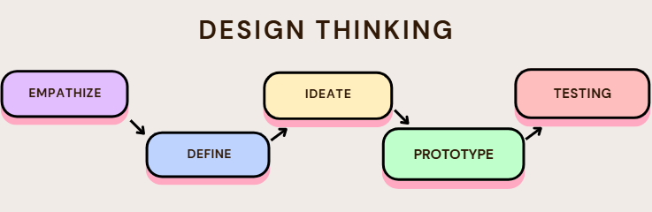

Figure 1.0: Design Thinking Phases

DETAILED STEPS

In November 2025, a task, Design Thinking Project, was assigned to create a prototype based on our topic, Student Engagement or Wellness Analytics. After a series of meetings and discussions, we managed to find the solutions that are related to our topic. We found that students often faced up and down in motivation, participation and mental wellness. Hence, the team aims to solve this challenge by developing a system to monitor students’ participation, motivation and mental health trends.

2.1 Empathize
As the first step, a Google Form survey was created to collect quantitative data on students’ participation in activities and stress levels. The survey was distributed through WhatsApp groups and one week was taken to collect the data from 70 respondents. Meanwhile, interview sessions were conducted with several UTM students to understand the needs and challenges faced by students in their level of study involvement and well-being. All the data and feedback obtained provided a foundation step for the project and will be used for the next step.

2.2 Define
In this step, the data gathered from the previous stage was analyzed through group discussions to identify the major issue. The challenges faced by students during their studies were identified. The problem statement is as follows, “Although students actively use digital platforms, the digital footprint data is not analyzed to identify patterns of low motivation, reduced participation, or early signs of stress. Without a centralized system to track these trends, students may fail to realize their mental well-being until it affects their academic performance.” With a clear problem statement established, the project proceeded to the next step of identifying potential solutions.

2.3 Ideate
After establishing a clear problem statement, the discussions were conducted to suggest solutions for the problems identified. The final solution is to build an application with useful features to monitor students’ involvement and mental wellness. The features include overall engagement, mood survey and calendar, attendance tracking, pulse rate, stress level, social engagement tracking, warning alert, assignment reminder, and weekly analysis report. The ideas generated from this step will be used in the next step to develop a prototype.

2.4 Prototype
In this phase, a prototype of the solution was developed based on the ideas identified in the Ideate phase. A low-fidelity prototype was created by first sketching the design on paper and then using Canva to incorporate more interactive features and elements. The prototype was intended to visualize the proposed solution and serve as a basis for user testing and feedback in the next phase.

Feature | Description
Overall engagement | An overview of student's overall engagement status, presented as the average percentage of wellness, engagement and social scores in a weekly report page.
Mood survey and calendar | Capture and record student's emotional state.
Attendance | Display student’s attendance in a calendar format, indicating whether classes were attended or missed.
Pulse rate | Detect student’s pulse rate by placing a finger on the rear camera to display the minimum, maximum and average pulse rate of a day, along with a line graph showing the average pulse rate over a week.
Stress Level | Display student’s stress levels based on pulse rate results, mood surveys, attendance, assignment, and social engagement. This feature is updated using average heart rate variability (HRV) and user feedback.
Social Engagement | Records and displays the total number of activities joined by the students and determines their level of participation. Suggestions also will be provided based on the social score.
Warning alert | Pop up when student’s overall engagement is low. The system identifies the potential reasons and suggests appropriate solutions. An ‘Ask for Help’ button is also provided to allow students to contact the counselors.
Assignment | Display all the ongoing or completed assignments and send reminders before the due date.
Weekly analysis report and survey | Focus on early detection and self-improvement by presenting weekly the students’ engagement, stress and social score. The histogram is also included to illustrate trends over weeks. The weekly survey also will be provided to continuously collect data about student’s updates.
Table 2.0: Prototype Features and Description

2.5 Test
Finally, the complete prototype was tested to determine its functionality and to ensure that all features worked smoothly. The initial testing was conducted by our team to identify errors and malfunctions. After that, user testing was carried out by allowing users to interact with the prototype. User feedback and experiences provided valuable insights for maintaining and improving the project and this process helped refine the prototype to better meet user needs.

DETAILED DESCRIPTION

Problem | In recent years, people are surrounded by stressful events, and most of them cannot be easily avoided. Students at all grade levels face pressure in their studies, this pressure is often greater for university students. They need to deal with the tasks related to handling heavy academic loads and complicated relationships.  Students are expected to complete their assignments and projects before deadlines and perform well in different courses. Meanwhile, it is expected that the students will participate in extracurricular activities, talks and programs. As a result, students may feel stressed, anxious and will be more distracted during their classes.  Even though students are very active in digital platforms such as e-learning, WhatsApp and other study apps, the data generated from these platforms is rarely analyzed to identify the signs of low motivation, less participation or early signs of stress. Since there is no central system to monitor this, students do not realize their mental health issues until it negatively impacts their academics.
Solution | To solve this problem, the team developed a solution to track students’ engagement and well-being. After generating different ideas, our team concluded that the implementation of a prototype named UniWell is the most necessary. A key feature of this solution is to monitor students’ motivation and stress levels. Students will be able to analyze data related to their academic involvement and well-being.  This app is really helpful because it gives tips to students related to stress and time management. It provides personal feedback, improvement advice, recommended activities and progress tracking. By centralizing this information in one platform, students can track their learning progress, stay motivated and maintain a balance between academic and personal life.
Team Working | Throughout the project, the team held meetings to brainstorm and share our ideas. After discussing the project title, we distributed tasks based on our strengths. We applied the five design thinking phases which are empathy, define, ideate, prototype and test to complete our task. During the empathy phase, we conducted interviews with four students and distributed surveys using Google Form to identify students’ needs and problems.  All team members agreed that good communication promotes teamwork and improves work efficiency. All the team members actively contributed to the discussions and updated each of the progress constantly through meetings, WhatsApp group and GitHub page. This helped us complete all the project requirements on time.

DESIGN THINKING ASSESSMENT POINTS
In order to ensure the assessment is able to evaluate the essential components of design thinking, plan carefully and structured development are required throughout the process. Therefore, the main objective of assessing the Student Wellness and Engagement Tracking Application is to evaluate how well the proposed solution addresses issues related to students’ stress, motivation and engagement.

Phases | Descriptions & Activities
- Empathize Phase | The team engaged in discussions to identify a problem that affects a large group of individuals instead of just a few users. Through observation and informal discussions, the team discovered that university students often experience academic stress, low motivation, and disengagement during the semester. This is normally attributed by heavy coursework, continuous assessments, and poor self-monitoring habits. As a result, students may struggle to maintain both academic performance and mental health. To understand these issues better, surveys were conducted using Google Forms to collect students’ opinions, experiences, and preferences related to stress management and academic engagement. Furthermore, interview sessions for better understanding student needs were conducted.
- Define Phase | The data from the surveys was analyzed. The purpose of this phase was to clearly identify the main problem faced by students. Based on the analysis, it was found that many students lack awareness regarding their stress and motivation levels. At the same time, students faced problems in maintaining consistent engagement throughout the semester. There was a lack of a system that would make it easy for students to monitor these issues.
- Ideate Phase | The team generates potential solutions to address the identified problems. During this phase, several solutions were suggested and their relevance and feasibility were evaluated. Solutions that were too complicated and did not suit the students’ needs were discarded. At the end of this phase, the team decided to develop a student wellness and engagement tracking application. The application aims to help students monitor their stress and motivation levels through daily check-ins and progress tracking.
- Prototype Phase | The team transforms the selected ideas into a tangible design. A low-fidelity prototype was developed using Canva to demonstrate the core functions of the application. The prototype allows users to record their daily stress and motivation levels and view their progress through a simple dashboard. Reminder features are also included to encourage balanced study habits and self-care. This design thinking solution is intended to be simple, interactive, and adaptable. The application can be further customized to suit different academic needs and student lifestyles, making it suitable for a wide range of users in higher education.
- Test Phase | The complete prototype is tested by multiple users to identify whether it meets the user needs and requirements. At the end of this phase, feedback from users is obtained and areas to be improved are identified.
Table 3.0 Design Thinking Assessment Points of Each Phase

DESIGN THINKING EVIDENCE

Empathy Phase

The team conducted an interview session with four students from UTM. The participants are summarized in the table below. Throughout the interview session, the team gained a deeper understanding of their learning engagement, weekly class participation and stress levels.
A Google Form survey was distributed to collect quantitative data on student engagement and motivation.

Name | Age | Faculty
Muhammad Hafiz bin Suhaili  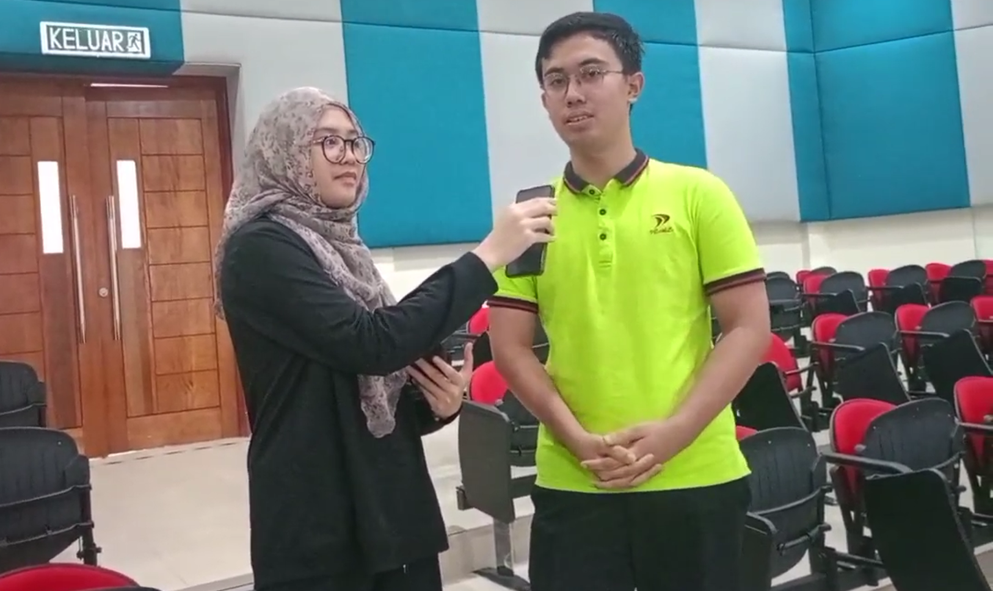 | 19 | Faculty of Computing
Emir Hakim bin Suhaimi  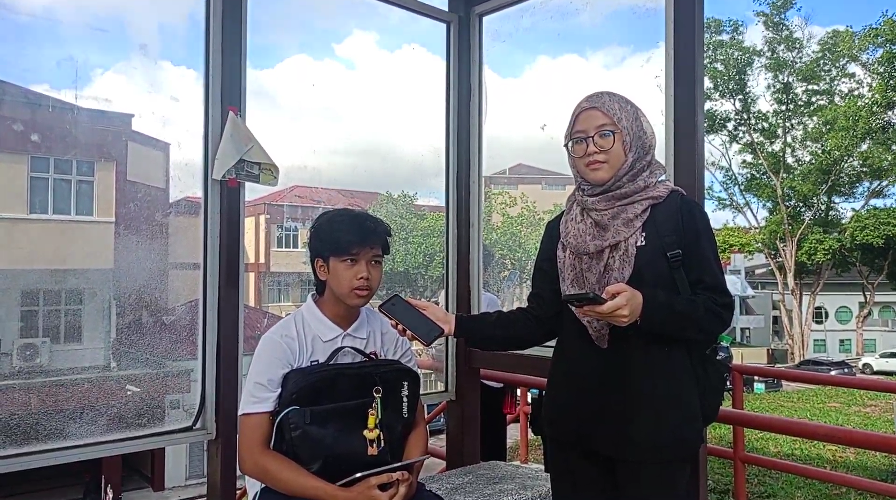 | 19 | Faculty of Chemical & Energy Engineering

Muhammad Rosham bin Samsulhadi  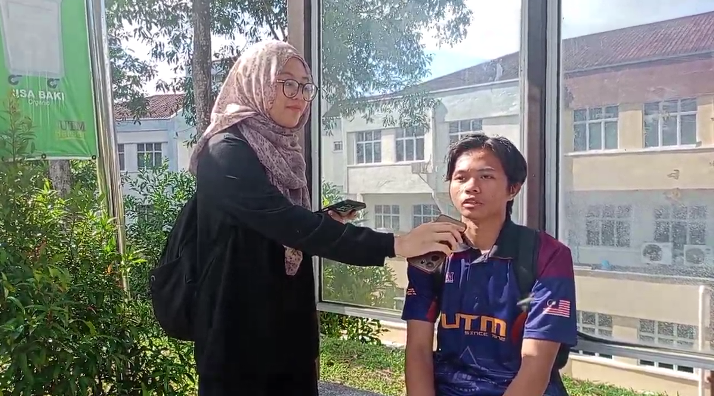 | 19 | Faculty of Chemical & Energy Engineering
Liew Ying Xin  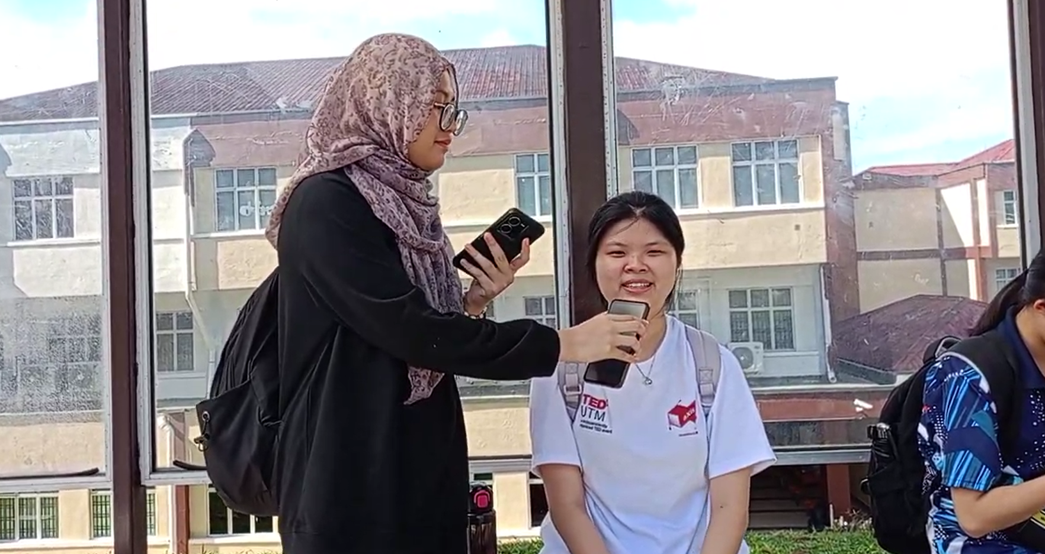 | 19 | Faculty of Chemical & Energy Engineering
Table 4.0: Background of the students interviewed

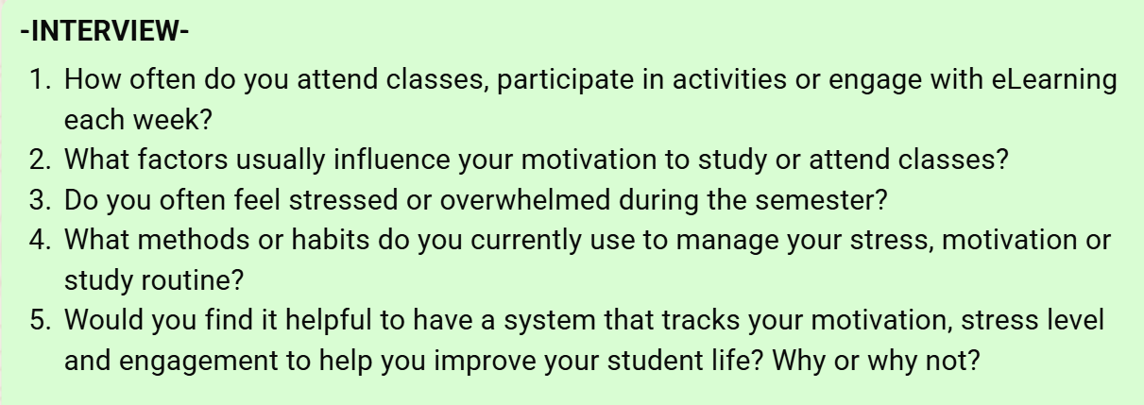
Figure 2.0: List of questions during interview

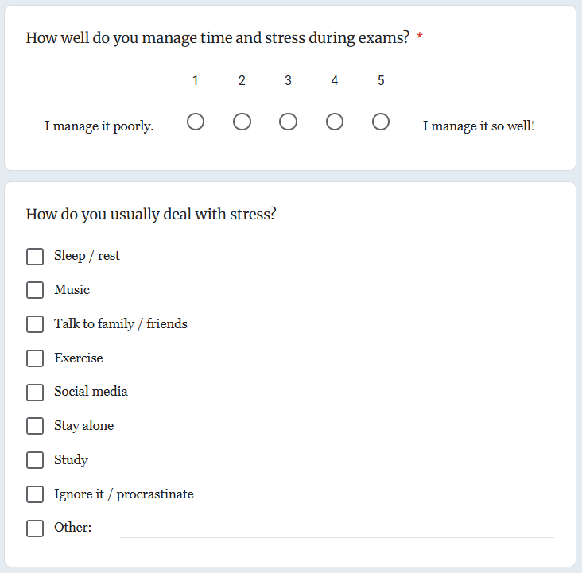
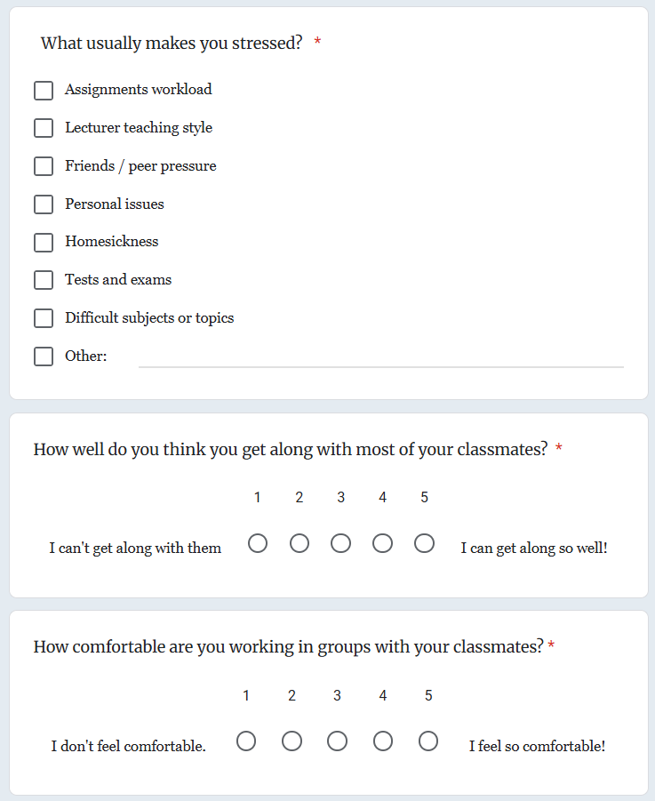
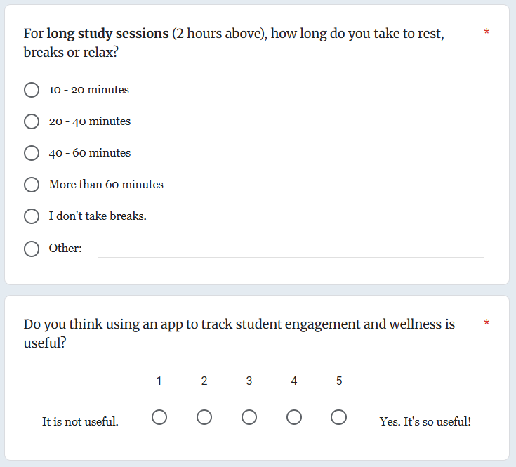
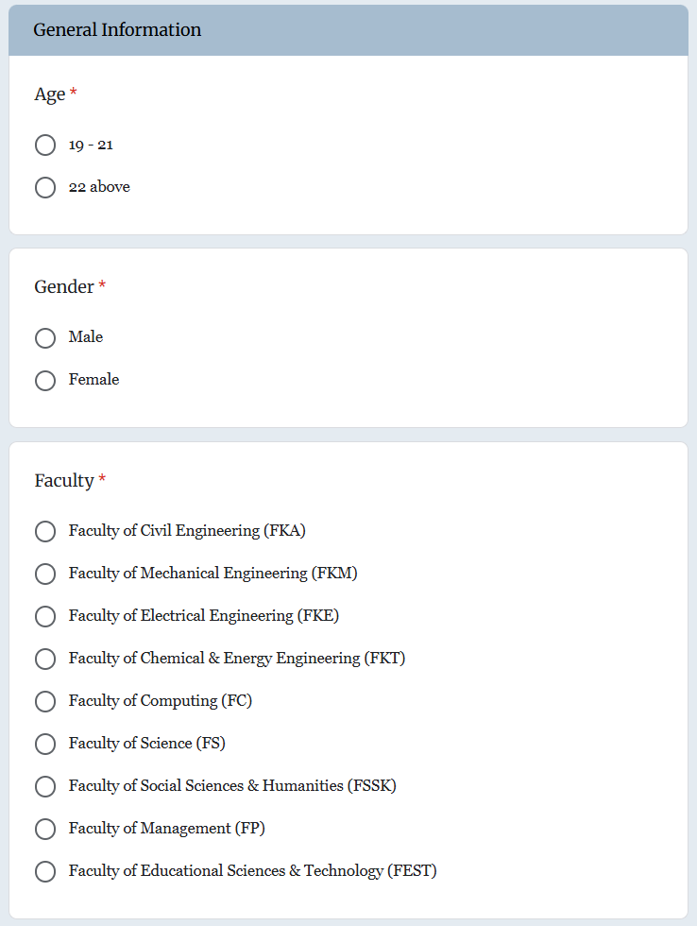
Figure 3.0

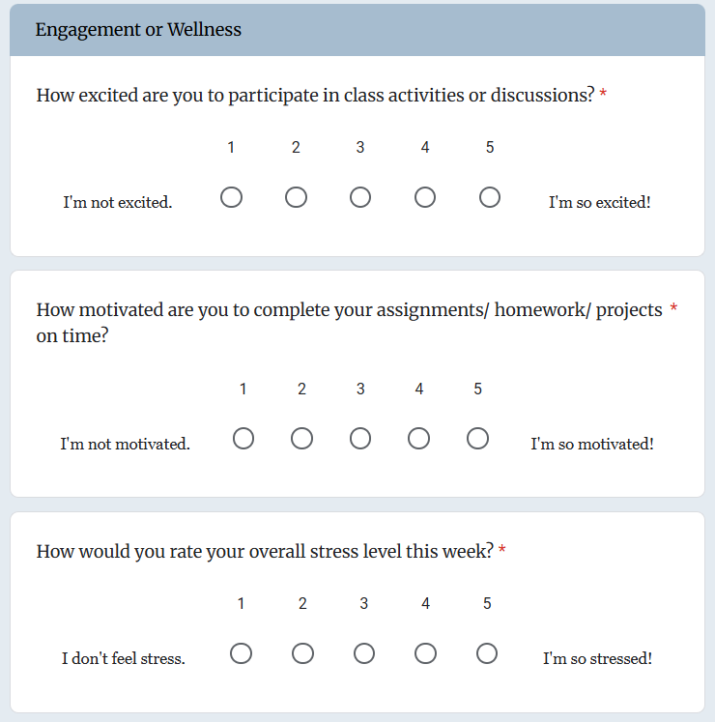
Figure 3.1

S
Figure 3.2

Figure 3.3

Figure 3.0 - Figure 3.3:
List of questions in Google Form
Define Phase

In this phase, the team gathered all the information from the interview sessions and Google Form survey. As a result, the main challenge faced by students and the problem is identified in order to design effective solutions.

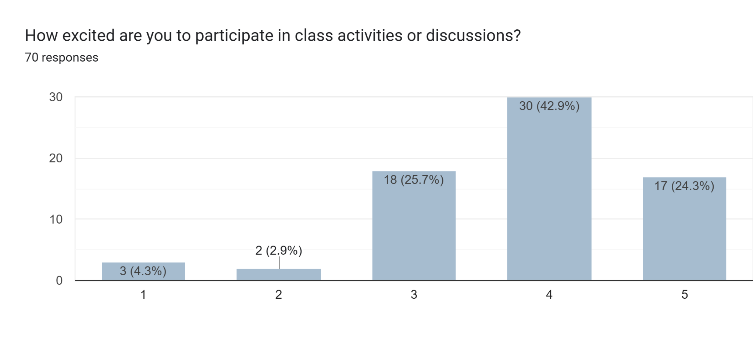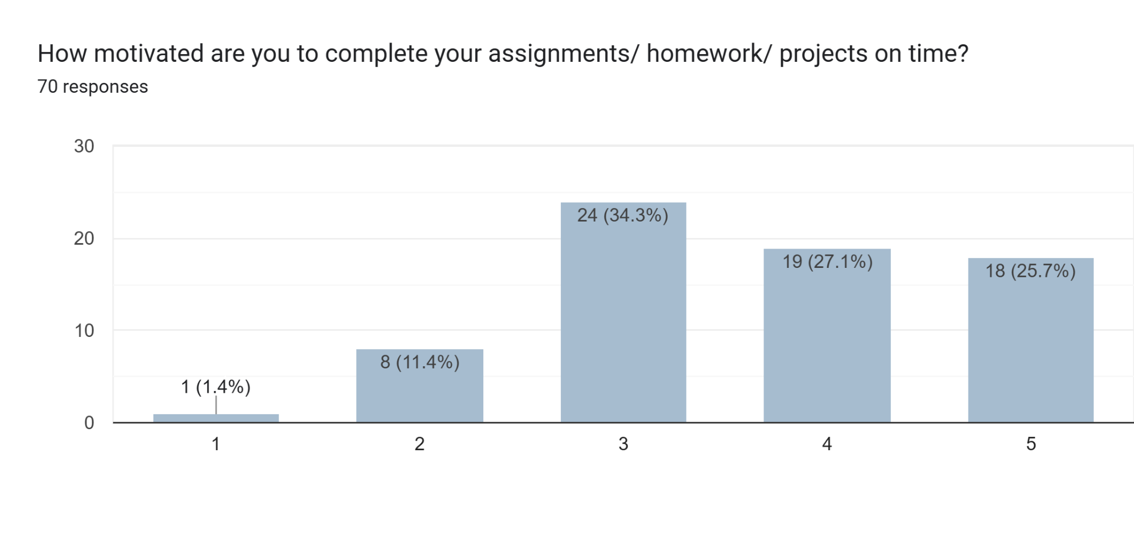
Figure 4.0
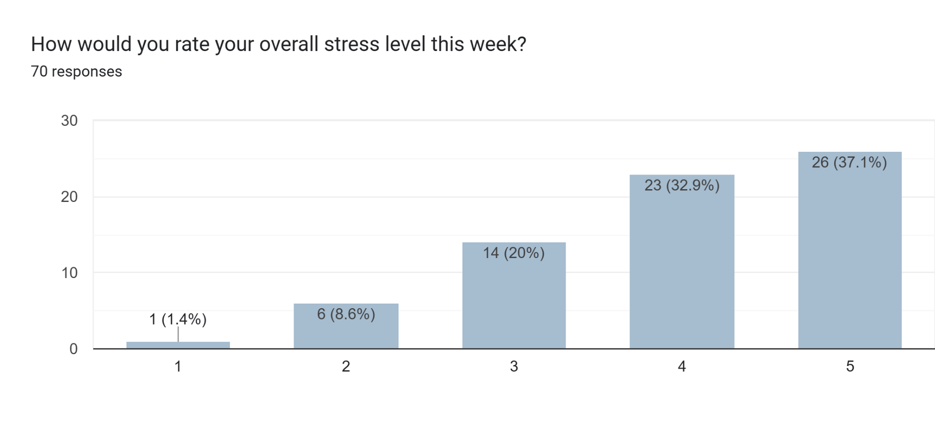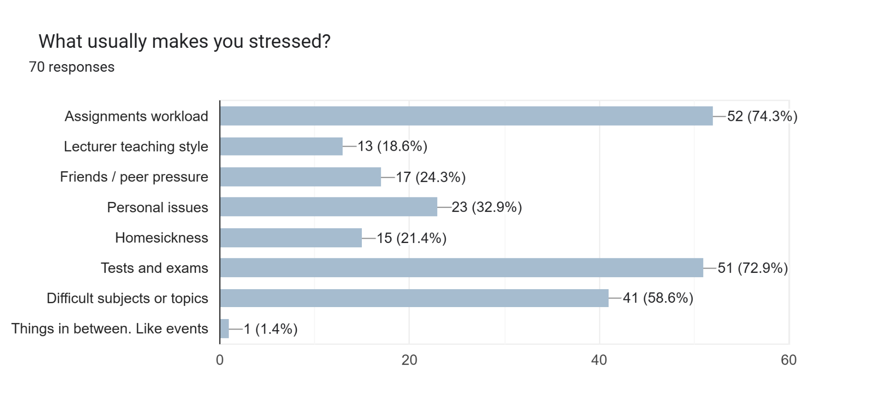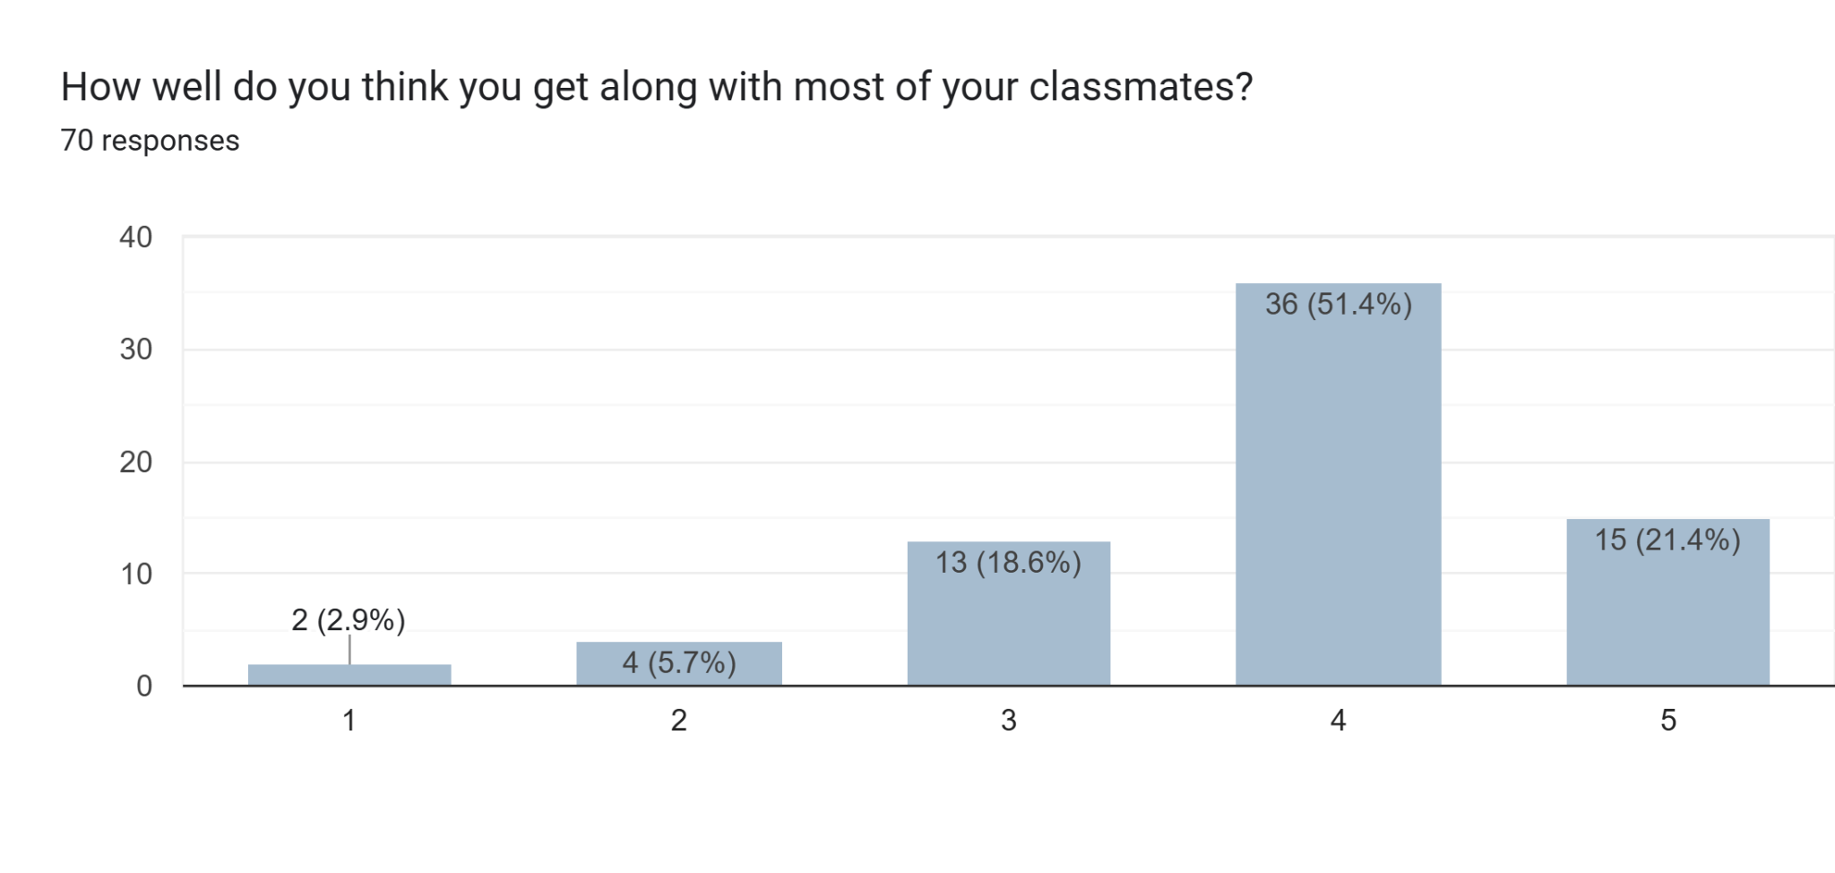
Figure 4.1
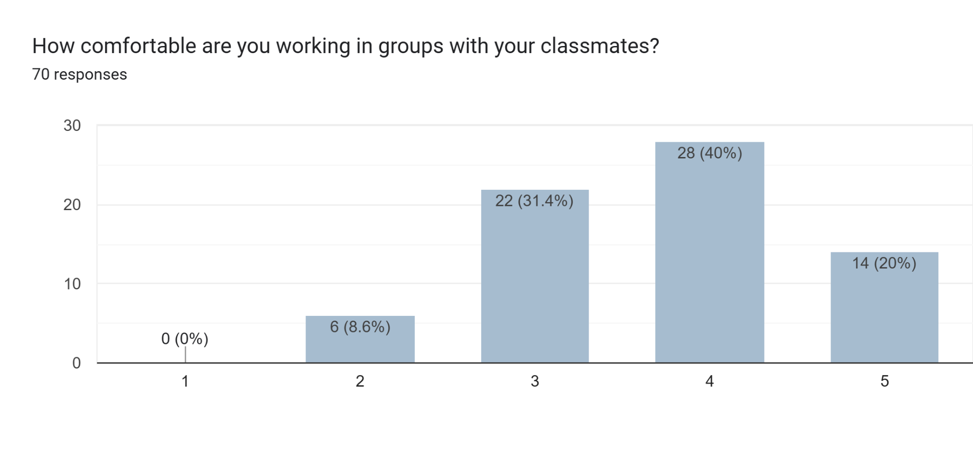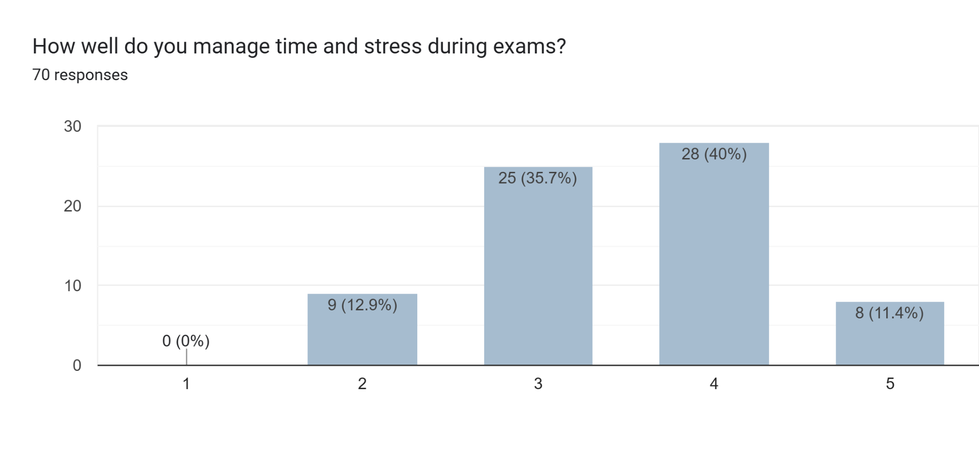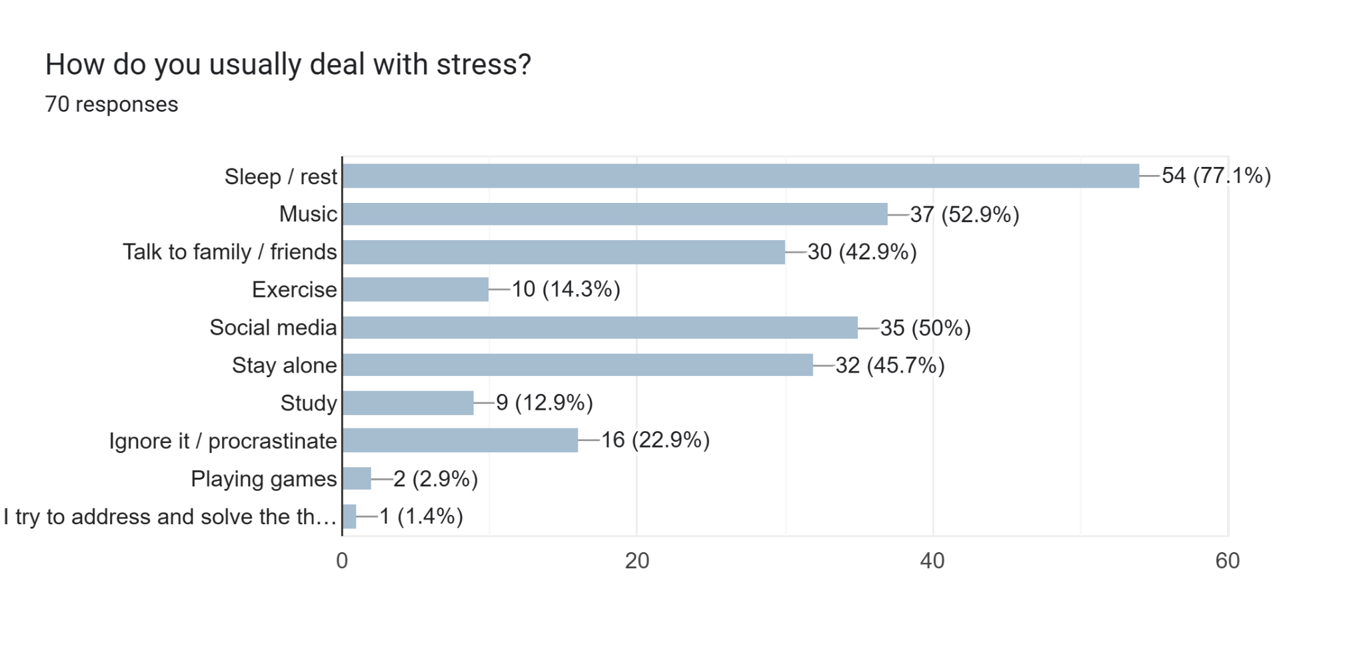
Figure 4.2
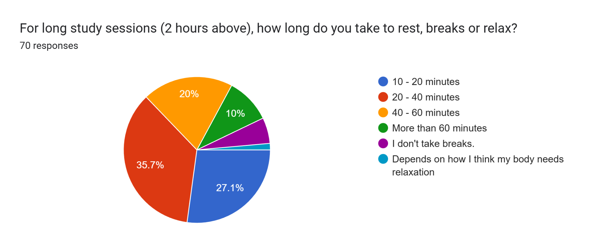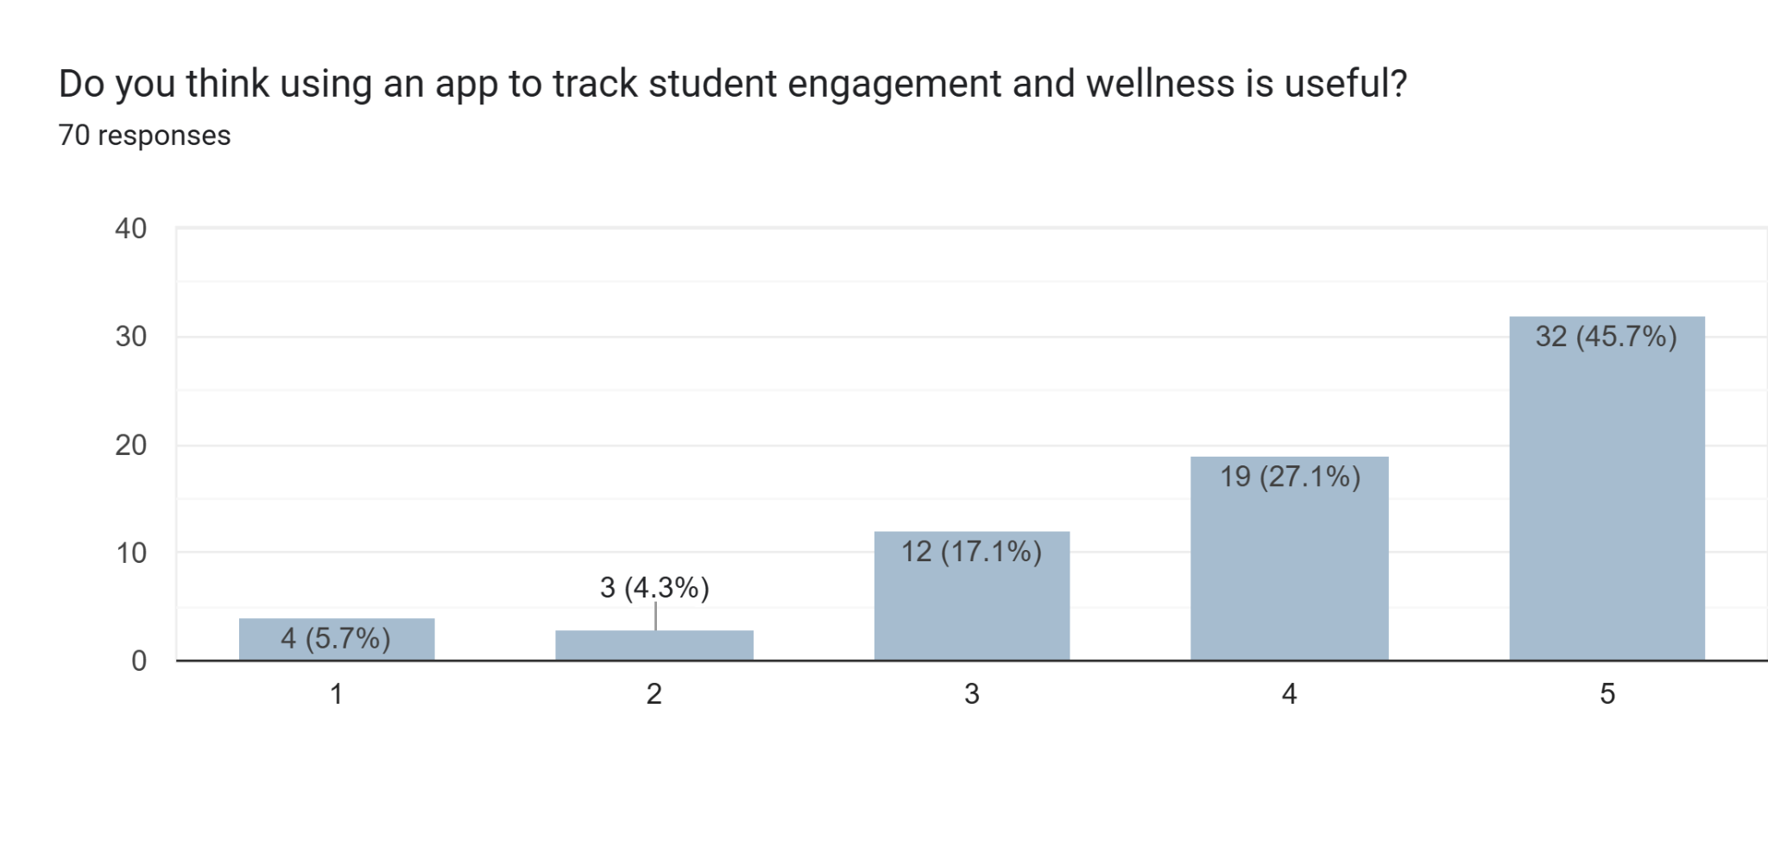
Figure 4.3

Figure 4.0 - Figure 4.3:
Results gathered from Google Form
Ideate Phase

During this phase, the team discussed and shared ideas to determine the most effective solution based on the problems identified in the previous phase. After evaluating all the ideas, we decided to develop a mobile app that tracks students' motivation, stress levels and engagement. This solution was chosen because it effectively addresses the main challenges identified and it is easy for students to use.

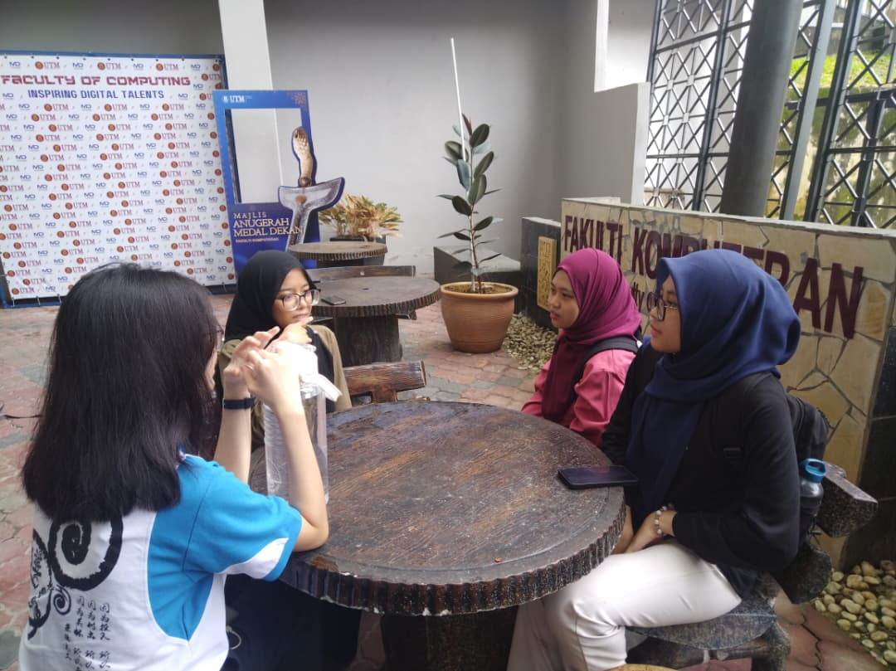
Figure 5.0: Brainstorming session
Prototype Phase

During the prototype phase, the team used the ideas from the Ideate Phase to build our prototype, which serves as a preliminary model of the mobile app. We ensured that our prototype always fulfills the users’ requirements.

Prototype | Evidences
Prototype Sketching | 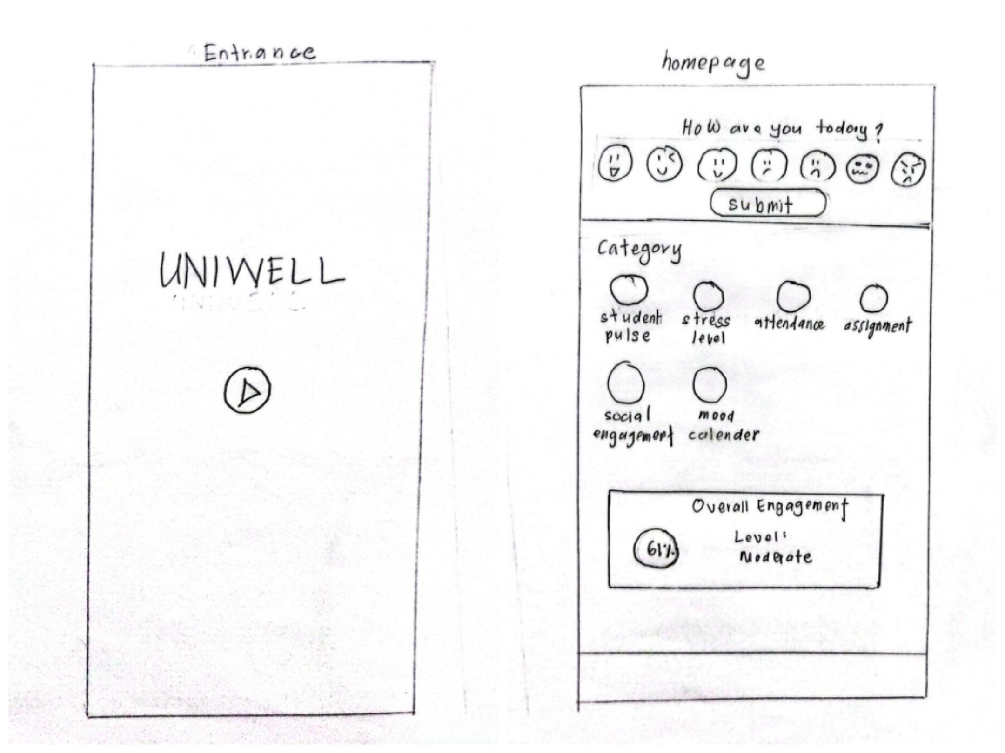  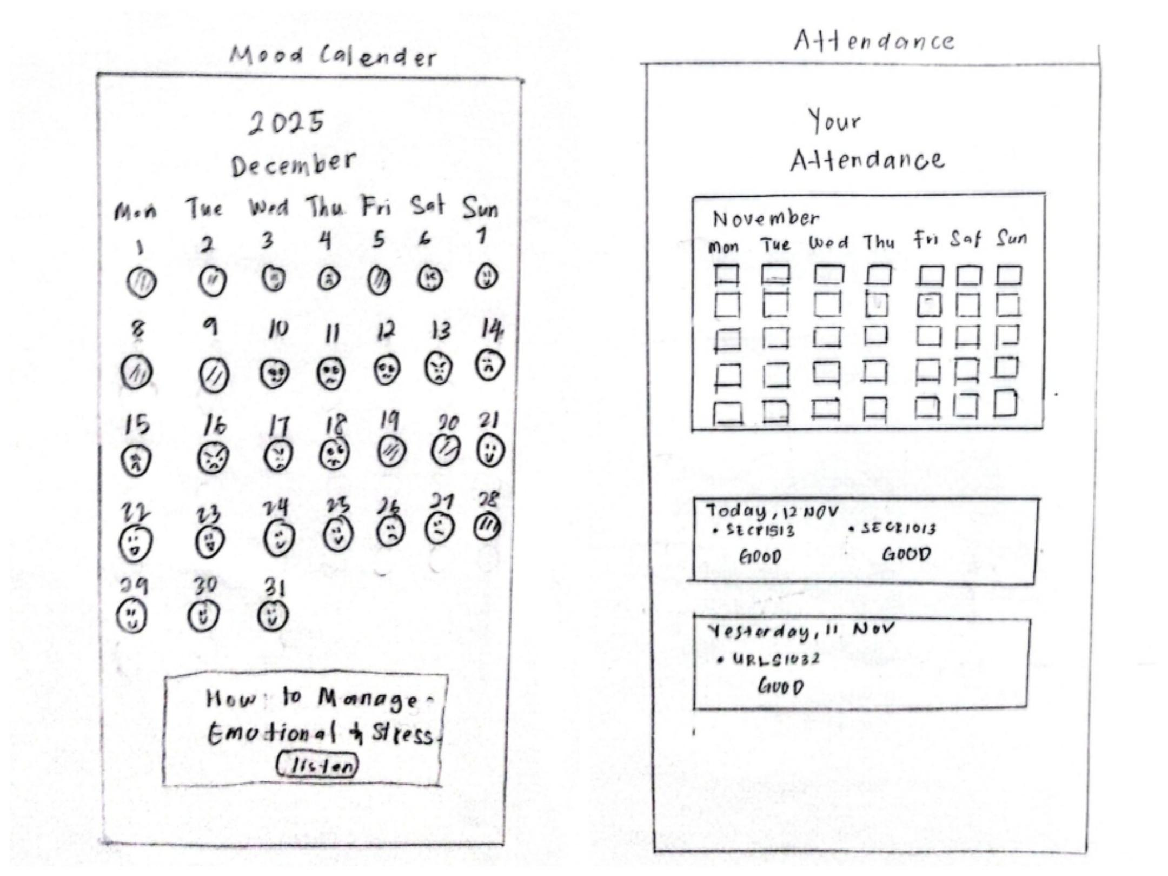  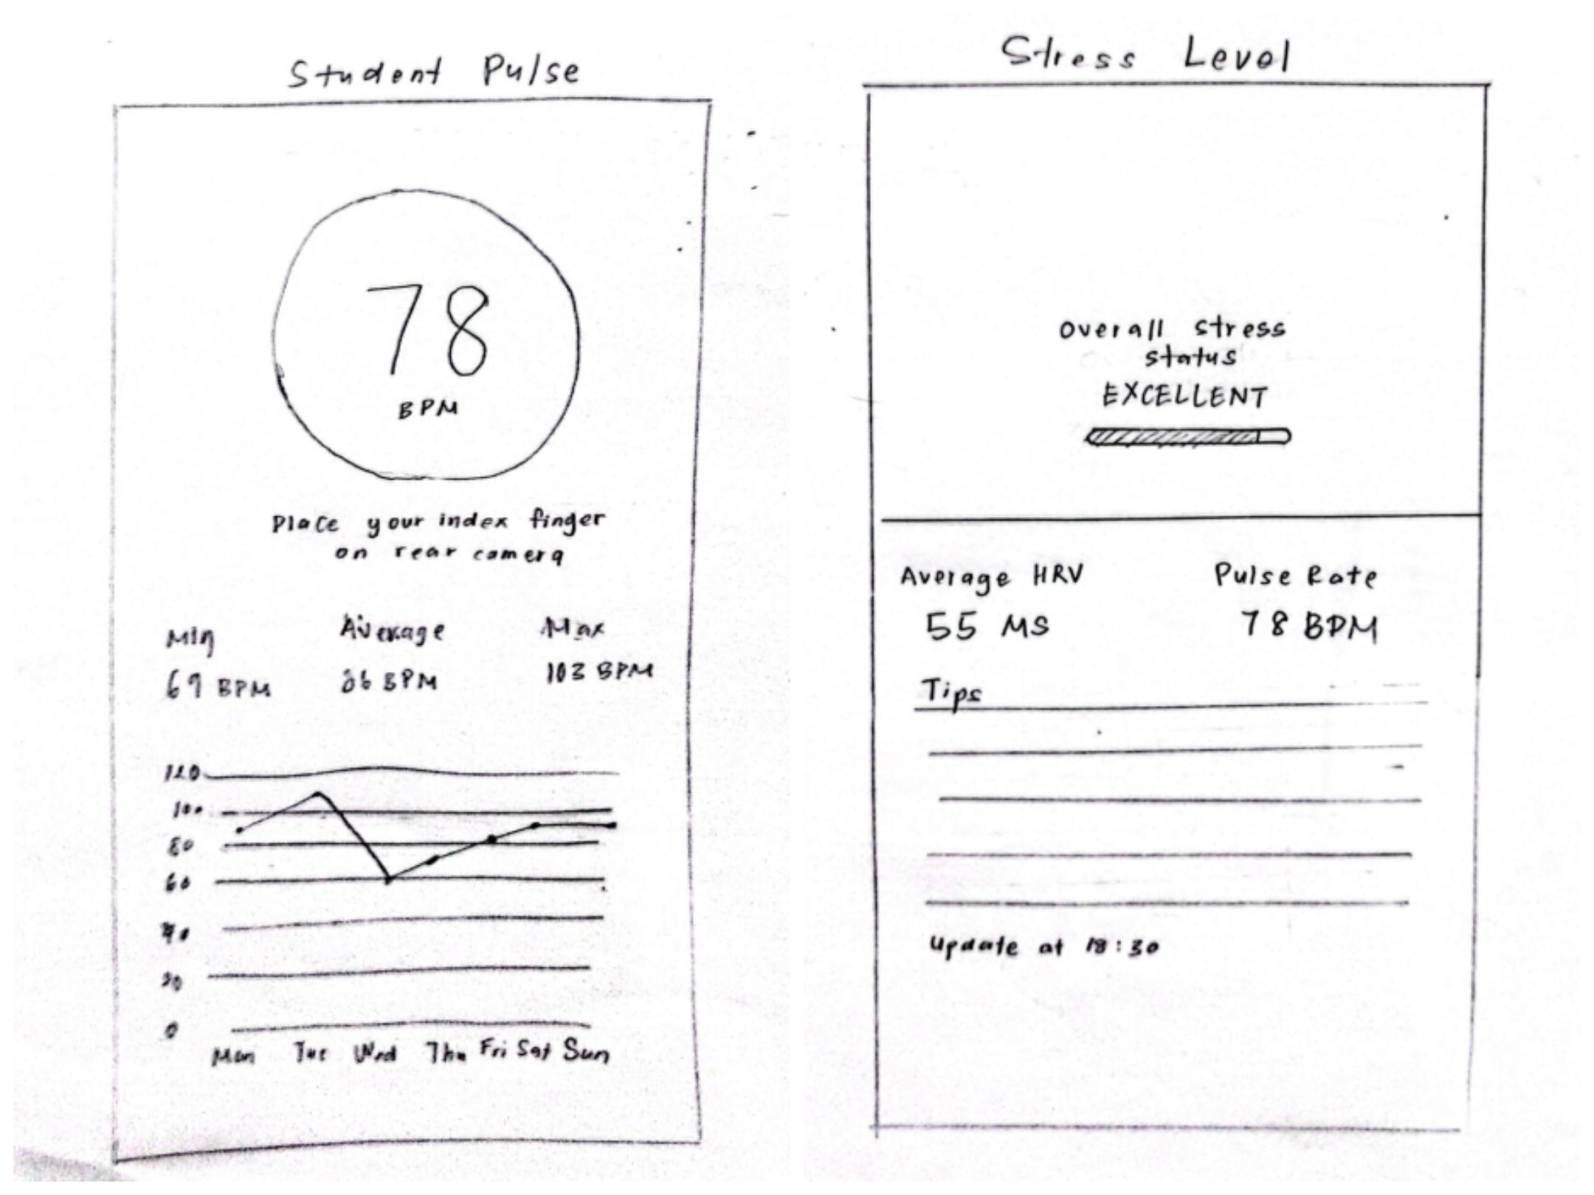  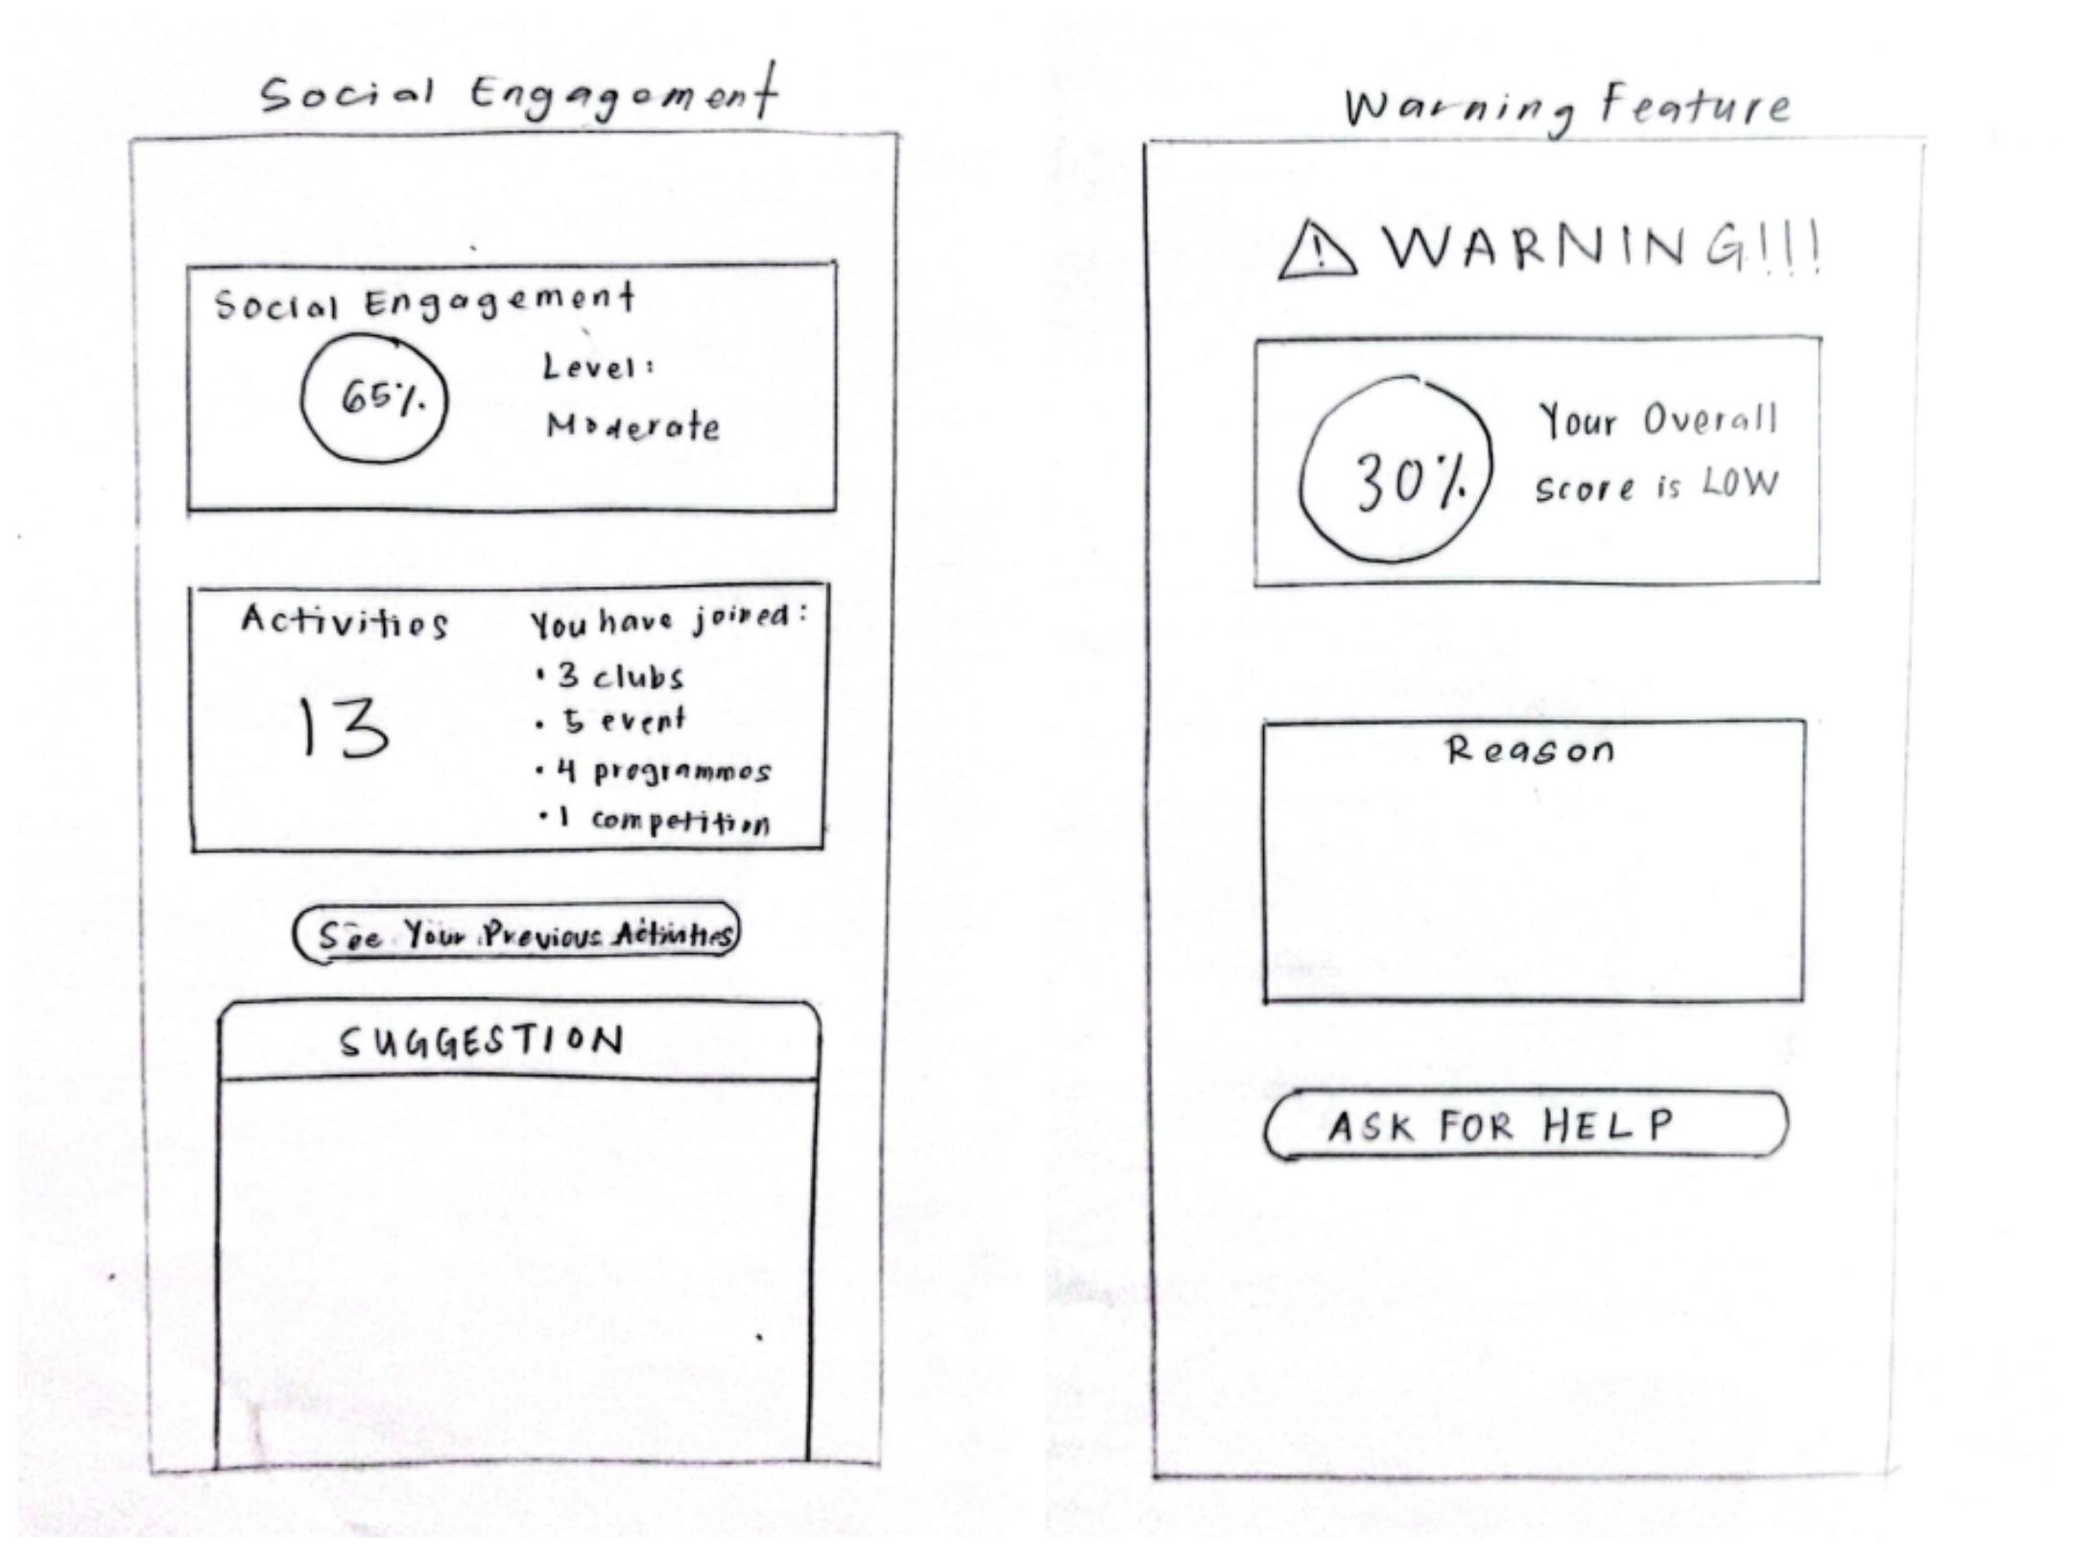  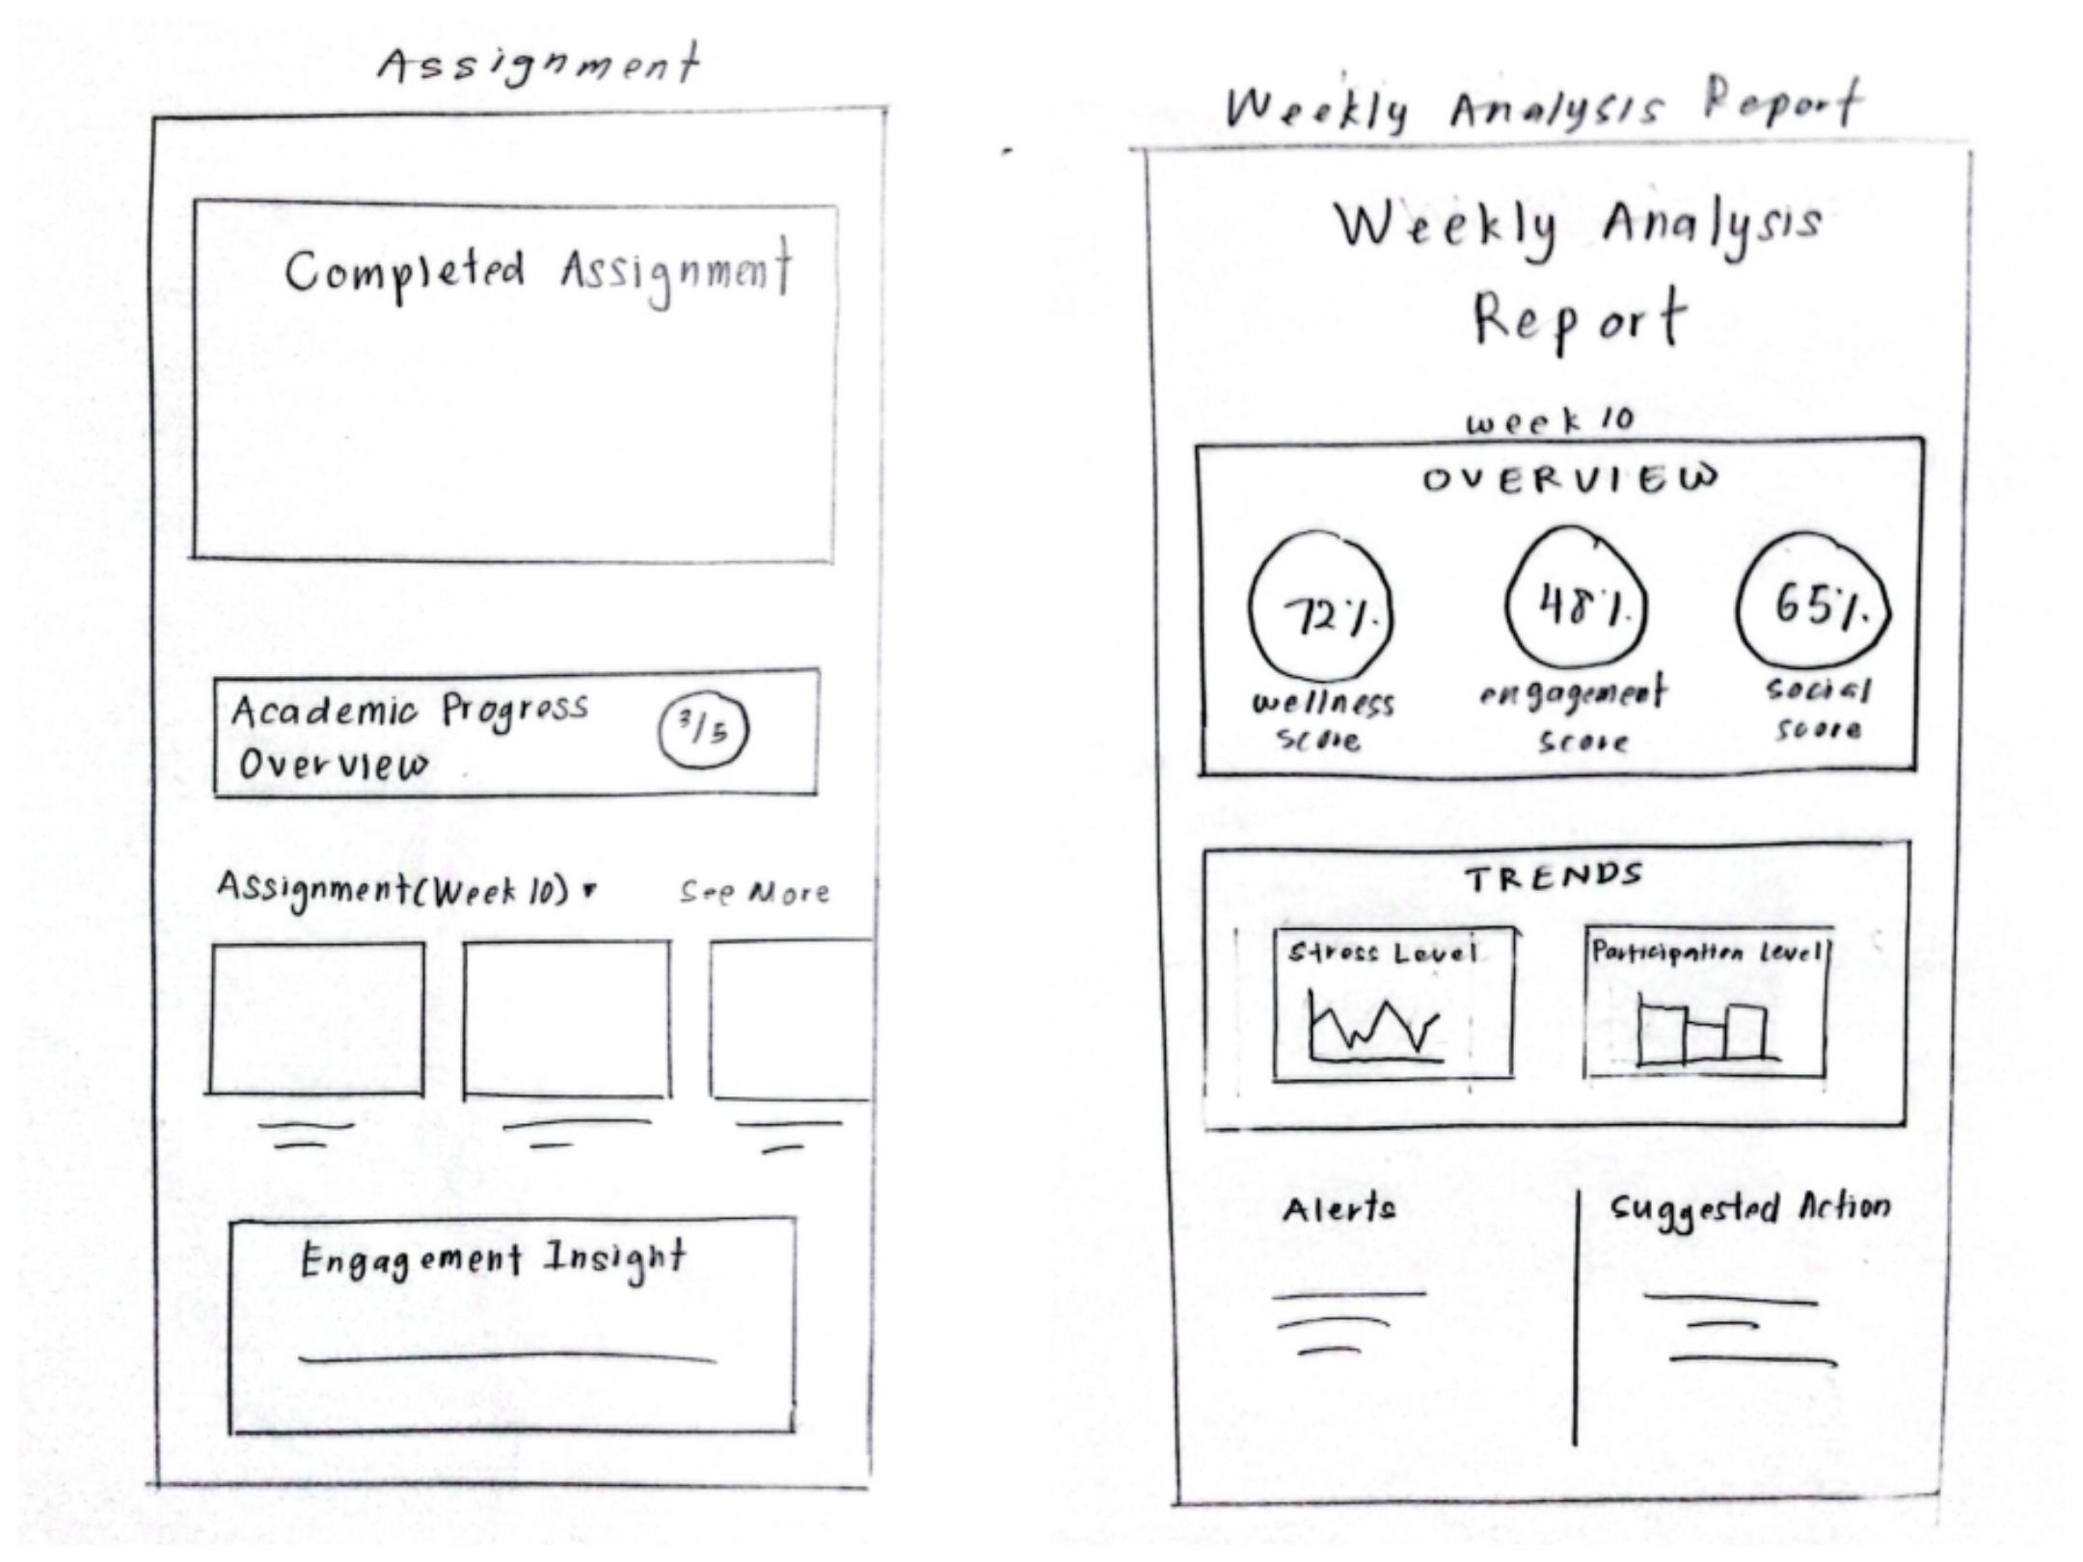
Digital Prototype (Canva) | 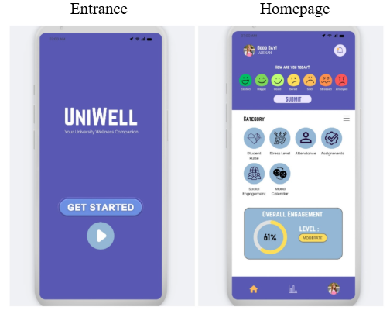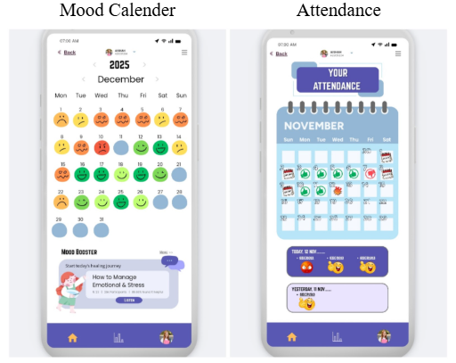  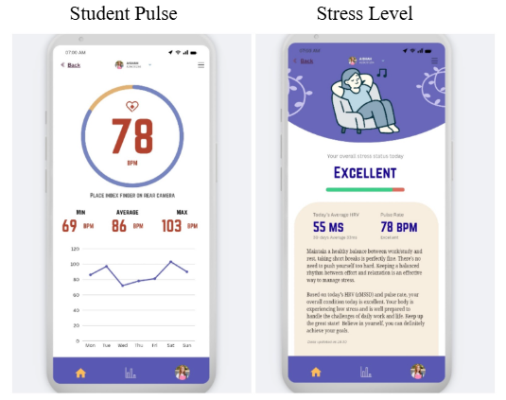  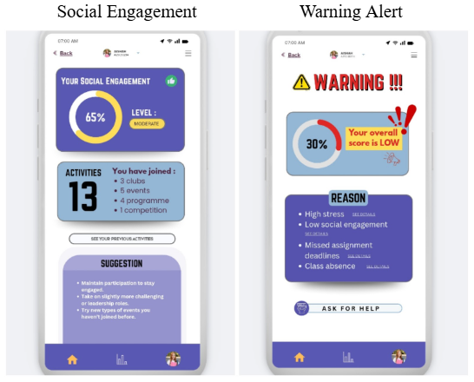  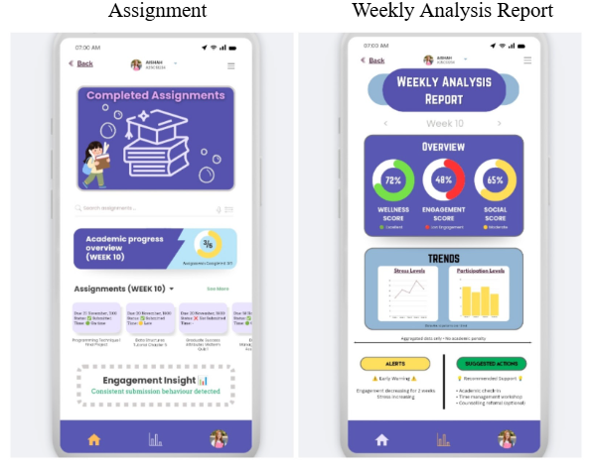
Table 5.0: Prototype Evidences

Test Phase

In this phase, the team asked several users to test our prototype. During testing, users interacted with the prototype and provided feedback on its functionality. Most users were surprised to find that the prototype could help them manage stress effectively and stay motivated throughout the semester.

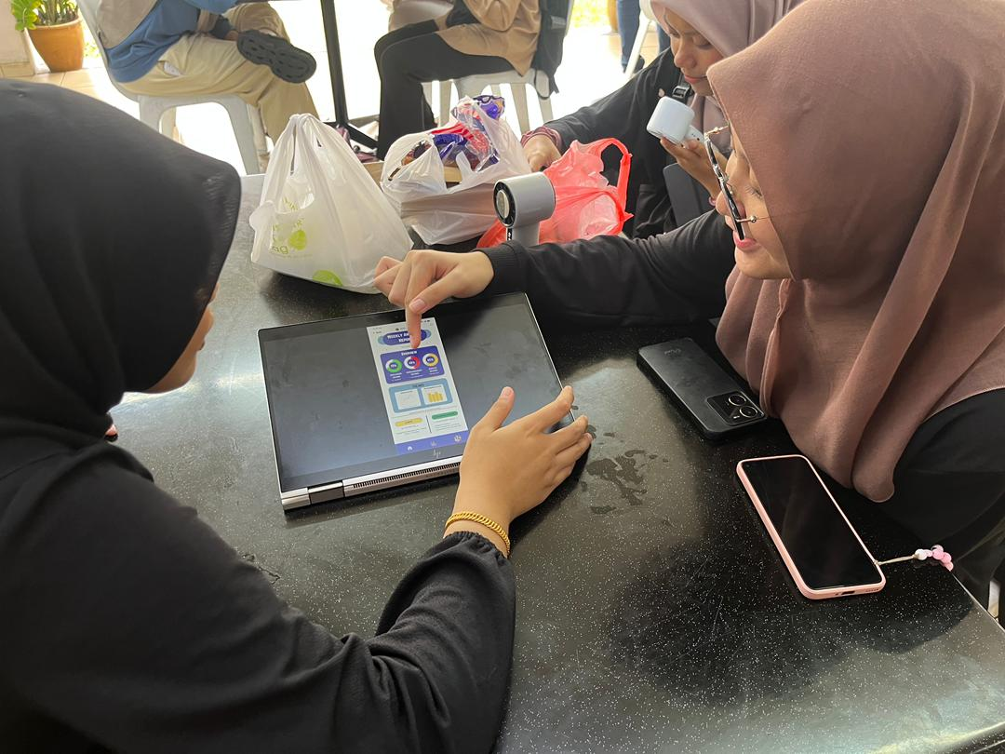
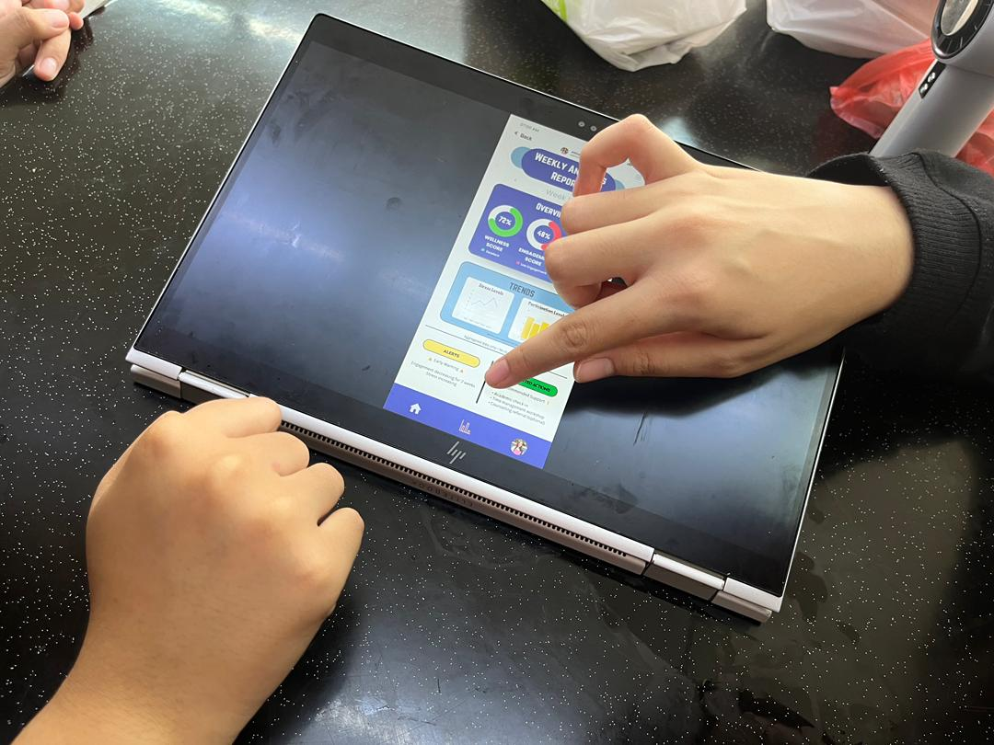
Figure 6.0: User testing the prototype

REFLECTION

Team Members | Reflections
Nur Nazirah Hanis binti Nazri (A25CS0319) | a. What is your goal/dream with regard to your course/program?  Nowadays, the industry doesn’t only require knowledge but also strong technical and soft skills. Therefore, my goal for this course is to gain exposure to real working environments and to learn useful skills that will benefit my future career. I also hope that this course could enhance my knowledge in Computer Science and improve my social skills especially in communication and problem solving.  b. How does this design thinking impact on your goal/dream with regard to your program?  Design thinking provides early exposure to the process of building a project. I get to learn step by step on how to build a project. It also helps me to gain real experience in conducting a project. Each phrase in Design Thinking guides the project planning process effectively. I am also able to enhance my communication skills through interviews and improve my teamwork skills when working together with my group members.  c. What is the action/improvement/plan necessary for you to improve your potential in the industry?  To improve my potential, I need to continuously work on my skills and knowledge. I could join activities and build my own project. I also need to strengthen my skills in conducting projects or programs, especially in proper planning, execution, documentation and presentation. Besides, improving my teamwork skills is also important as real working life requires us to work together as a team.
Humayra’ binti Zulqarnain (A25CS0068) | a. What is your goal/dream with regard to your course/program?  My dream is to be a more holistic and well-rounded individual by improving my communication skills, problem solving, creativity and leadership so that I can appear more confident and trustworthy to my connections. Furthermore, I also aim to master key skills and concepts necessary to become a competent computer science graduate.  b. How does this design thinking impact on your goal/dream with regard to your program?  Design thinking encourages me to approach problems in a more user-centered way. It helps me develop critical thinking skills and understand how to identify real problems through empathy, creating effective solutions, and continuously improving them through feedback and iteration. This approach not only strengthens my problem-solving abilities but also enhances my communication and teamwork skills, which are both essential to achieve my goal of becoming a confident and capable computer science graduate.  c. What is the action/improvement/plan necessary for you to improve your potential in the industry?  I plan to try and take initiative when it comes to presenting my ideas in front of people to improve my communication and teamwork skills. Moreover, I aim to be more participative in extra-curricular activities or clubs and discussions to gain more experiences and connections, which are just as important as technical skills for professional work purposes.
Ng Xuan Yee (A25CS0291) | a. What is your goal/dream with regard to your course/program?  My goal is to improve my communication skills so that I can speak confidently in front of others. I hope to learn more about data analysis and web design because I’m very interested in these areas. Besides that, I also want to understand today’s technologies so that I can work with a lot of data and be successful in the field of computer science in the future.  b. How does this design thinking impact on your goal/dream with regard to your program?  This project helped me to improve my problem-solving skills by allowing me to work on problems that happen in the world. Through data collection and analysis processes using Google Forms, I learned how to analyze data effectively and this helped me understand data better. Moreover, this project also enhanced my communication and collaborations skills among my team members. It embraces me to exchange ideas and listen to different opinions from my team members. All of these support my goal of becoming a professional data engineer.  c. What is the action/improvement/plan necessary for you to improve your potential in the industry?  To improve my potential in the industry, I need to consistently improve my soft skills and technical skills. Improving my communication skills is my top priority. I plan to achieve this by actively participating in class presentations, speaking confidently and keeping eye contact throughout conversations. At the same time, I plan to strengthen my programming skills and tools such as C++, Java, HTML and Microsoft 365. Furthermore, I plan to attend more workshops and programs that could improve my practical skills to stay updated and remain competitive in this quickly changing industry.
Nur Hanani Sazwani binti Muhammad Helmi Wan (A25CS0313) | a. What is your goal/dream with regard to your course/program?  My goal in this course is to develop strong technical and problem-solving skills so that I can become a competent professional in my field. I want to gain knowledge and hands-on experience to create technology solutions that solve real problems, especially those related to student learning and well-being. In the future, I hope to work in a technology-driven industry where I can contribute meaningfully and keep improving myself.  b. How does this design thinking impact on your goal/dream with regard to your program?  Working on the student engagement and wellness analytics app prototype taught me how design thinking helps connect user needs with technical solutions. It showed me the importance of understanding real problems, such as students’ motivation and stress levels, before creating a system. This approach encourages me to focus on user experience, continuous improvement, and practical outcomes, which supports my goal of becoming a problem-oriented and industry-ready graduate.  c. What is the action/improvement/plan necessary for you to improve your potential in the industry?  To improve my potential, I plan to practice more on building simple applications and using data analytics to create meaningful insights. I also want to enhance my skills in documenting and presenting ideas clearly, so my solutions can be well understood and implemented. Besides technical skills, I aim to improve my communication skill and teamwork abilities to work better in real industry environments. Finally, I will keep learning about new technologies and trends to stay relevant.

TASK DISTRIBUTION

No. | Team Members | Task
1. | Nur Nazirah Hanis binti Nazri  A25CS0319 | - Prototype design  - Prototype sketch  - Create survey form  - Report Writing (Detail Steps)
2. | Humayra’ binti Zulqarnain  A25CS0068 | - Prototype design  - Conduct interviews  - Report Writing (Introduction, Conclusion)
3. | Ng Xuan Yee  A25CS0291 | - Prototype design  - Report Writing (Detailed Description, Design Thinking Evidence)  - Create interview questions
4. | Nur Hanani Sazwani binti Muhammad Helmi Wan  A25CS0313 | - Prototype design  - Video editing  - Report Writing (Design Thinking Assessment Points)  - Videographer

CONCLUSION

Student engagement and well-being is crucial to maintain academic success and overall growth. However, students may face challenges such as stress and social engagement which often go unaddressed due to a lack of an effective monitoring system.

Through design thinking, a low-fidelity prototype was developed through multiple phases which are empathizing, defining, ideation, prototyping and testing. Through Google Forms and interviewing students from different faculties, a prototype using Canva and sketches of the application on paper was created to demonstrate the usage of the application to students.

Key learning outcomes include an improved understanding on creating a user-centered design, the ability to translate qualitative feedback into quality system features, enhanced creative and problem-solving skills, improved teamwork and communication skills, and that iterative and testing are important to ensure impactful and user-focused solutions.
REFERENCE

No. | Reference
1. | Neagu, S. N., & Vieriu, A. M. (2025). Digital and Psychological Well-Being Among Technical University Students: Exploring the Impact of Digital Engagement in Higher Education. Education Sciences, 15(9), 1192. https://doi.org/10.3390/educsci15091192
2. | Axelson, R. D., & Flick, A. (2010). Defining Student Engagement. Change: The Magazine of Higher Learning, 43(1), 38–43. https://doi.org/10.1080/00091383.2011.533096
3. | Taylor, L. & Parsons, J. (2011). Improving Student Engagement. Current Issues in Education, 14(1). http://cie.asu.edu/
4. | IxDF - Interaction Design Foundation. (2016, May 25). What is Design Thinking?. IxDF - Interaction Design Foundation. https://www.interaction-design.org/literature/topics/design-thinking

VIDEO LINK
https://youtu.be/GthMQMXqYpA?si=qv-kQYtly2aeutb

